1. **Screenshots**

Screen 1: – Edit/View Provider Inquiry

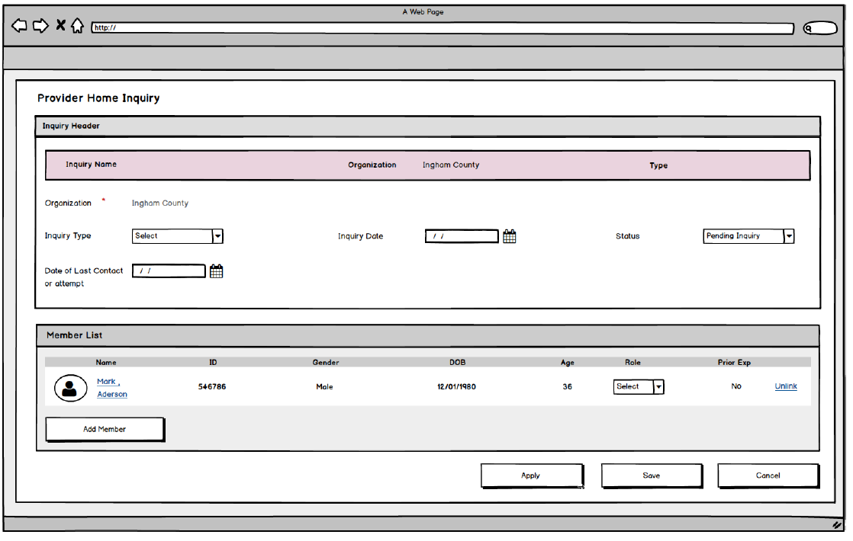

* + 1. **Screen Fields**

| **Class.Attribute Name** | **To Be**  **Display Name** | **Type** | **Align** | **Size** | **Read**  **Only** | **Calculation** | **Edit Mask** | **To Be**  **UI Validation** |
| --- | --- | --- | --- | --- | --- | --- | --- | --- |
| N/A | Inquiry Header |  |  | N/A |  |  |  | Group Header |
| Person.lastName,Person.firstName,Person.middleName | Inquiry Name | Display text |  | 100 | T | Use Person.lastName,Person.firstName,Person.middleName where roleId is Inquirer1 | Last + “, “ + First + “ “ + Middle | System derived.  Defaults to blank until initial save. |
| ProviderInquiry.agencyId | Organization | Display text. |  | 100 | T | Use Agency Name from Agency table  Name of the Organization to which the Inquiry is attached. |  | System derived.  Defaults to the Organization of the logged in user. Not editable. |
| ProviderInquiry.inquiryTypeCode | Type | Display text. |  | 60 | T |  |  | System derived. |
|  |  | Display text. |  | 30 | T |  |  |  |
| ProviderInquiry.agencyId | Organization | Display text. |  | 100 | T | Use Agency Name from Agency table  Name of the Organization to which the Inquiry is attached. |  | Required field.  Defaults to the Organization of the logged in user. Not editable. |
| ProviderInquiry.inquiryTypeCode | Inquiry Type | Dropdown List |  | 30 | F | **Domain Code:** InquiryType |  | Required field.  Default is <blank> when creating a new Inquiry. |
| N/A | N/A | String |  | 30 |  | **Domain Code:** InquirySubType |  | Required field.  Default is <blank> when creating a new Inquiry. |
| ProviderInquiry.inquiryDate | Inquiry Date | Date field |  | 10 | F |  | MM/DD/YYYY | Required field.  Default is <blank> when creating a new Inquiry. |
| ProviderInquiry.decisionCode | Status | Dropdown List |  | 30 |  | **Domain Code:** InquiryStatus |  | Required field.  Defaults to Pending on an Add  No other value can be selected prior to saving the Inquiry. |
| ProviderInquiry.decisionReasonText | Cancellation Reason | Dropdown List |  | 30 | F | **Domain Code:** InquiryCancelReason |  | User selected.  Conditionally required if Status is Canceled. |
| ProviderInquiry.noContactDate | Date of Last Contact or Attempt | Date field |  | 10 | F |  | MM/DD/YYYY | User entered.  Conditionally required if Status is Canceled. |
| N/A | Member List |  |  | N/A |  |  |  |  |
| Person.personId | ID | Display text |  | 22 | T |  |  |  |
| Person.lastName,Person.firstName,Person.middleName | Name | Display text |  | 100 | T | Use Person.lastName,Person.firstName,Person.middleName | Last + “, “ + First + “ “ + Middle | System derived. |
| Person.genderCode | Gender | Display text |  | 30 | T |  |  | System derived. |
| Person.birthDate | DOB | Display text |  | 10 | T |  | MM/DD/YYYY | System derived. |
| N/A | Age | Display text |  | N/A | T | Computed in years based on the Member’s DOB and the system date when the record is accessed. |  | System derived. |
| InquiryParticipant.roleCode | Role | Dropdown List |  | 30 | F | **Domain Code:** InquiryRoleType |  | System derived. |
| InquiryParticipant.priorExperience | Prior Exp. | Display text. |  | 3 | T | Calculated indicator of Yes, based on whether the Member was previously an active Member on another Provider Home during a period of time in which that Provider Home had one or more children placed for services. |  | System derived. |

* + 1. **Action Buttons/Hyperlinks**

| **Label** | **Type** | **On Click Action/Navigation** |
| --- | --- | --- |
| Add Member | Button | Navigates to Person Search, and returns information from a successful search. |
| Unlink(Member) | Hyperlink | Unlinks the member from the inquiry |
| Name | Hyperlink | Navigates the user to the Person Overview page |

**Story**

As an Inquiry Worker, I want to create inquiry records so that I can document basic inquiry demographic details.

**3.1 Points to Note**

N/A

**3.2 Demo Steps**

1. Login to the USFN application with the following credentials

Username: samweaver

Any Password works.

1. The My Organizer is displayed after successful login.
2. Click on the provider tab.
3. Click on the Inquiry which will navigate to Inquiry list page.
4. Click on the Add Inquiry Button then you will navigate to provider home inquiry page.

**4. Acceptance criteria**

**4.1 Screen 1 Acceptance criteria**

|  |  |  |  |
| --- | --- | --- | --- |
| # | Requirement | Execution Event | Status |
| 1. 1 | When the Provider Home Inquiry tab is first opened in Add mode, no other tabs are visible until the Inquiry record is successfully saved. | Save/Apply |  |
| 1. 2 | One and only one member must be identified with the role Inquirer 1 for the inquiry record to be saved. | Save/Apply |  |
|  | Once an Inquirer 1 has been designated for the inquiry record, and the record has been successfully saved, the Inquirer 1 Role cannot be modified. | Save/Apply |  |
|  | Up to two individuals can be given the role of Inquirer 2 on the inquiry record. The unlink will appear once the inquirer two has been added. | Save/Apply |  |
|  | Addresses are not directly attached to the Inquiry record. The information on the Address screen is populated from the primary “Residence” address information attached to the Inquirer 1. | Save/Apply | Where is the address section on the prototype? |
|  | An Inquiry record cannot be saved until a Residence Address with a Status of Primary Address is attached to the Person record for the Member identified as the Inquirer 1. | Save/Apply | Where is the address section on the prototype? |
|  | An Inquiry record cannot be saved until an active Phone Number (contact information) is attached to the Person record for the Member identified as the Inquirer 1. This means that the person must have a linked Contact Record that has a Contact Type of Work, Home, or Cell. | Save/Apply | This field is not available on the prototype |
|  | The Provider Inquiry Status cannot be changed to Pending Approval or Canceled until a Referral Source has been identified. | Save/Apply |  |
|  | Once an Inquiry Record has been updated to a “Pending Approval” status, the Inquiry Type value cannot be changed. |  |  |
|  | When the Status of a Provider Inquiry is Completed, the entire Inquiry record is frozen. | Save/Apply |  |
|  | The system must give the worker a message that the Inquiry cannot be changed to Pending Approval status if the Inquirer 1 or Inquirer 2 is already a Member of another Inquiry which is in Pending Approval status. | Save/Apply |  |
|  | A Provider Inquiry record cannot move to a Status of Pending Approval if the Inquiry Provider Inquirer 1 or Inquiry Provider Inquirer 2 is an active member of an existing Provider Home Inquiry that has a Status of Pending Approval | Save/Apply |  |
|  | When the Provider Inquiry is opened in Add Mode, the default value for Status is Pending Inquiry. | Save/Apply |  |
|  | A Provider Inquiry cannot be saved unless the first and last name, the DOB, and Gender have been recorded for the person with the role of the Inquirer 1. | Save/Apply |  |
|  | The following Activity Types must be recorded in order to change the status to Pending Approval:  1. Welcome Packet sent  2. Orientation completed  3. Application sent  4. Application received | Save/Apply |  |
|  | If all the following conditions are met, an indicator for Prior Experience is displayed with the value of Yes.   * A Member has been previously attached to a Provider Home with the role of either Inquirer 1 or Inquirer 2. * There were one or more Child Placements in that Provider Home while the Member had one of these roles in the Member list for the previous Provider record. | Save/Apply  Which tables in DB will the validations happen? |  |